St Margaret Mary’s Secondary



Pupil Improvement plan
2025/26
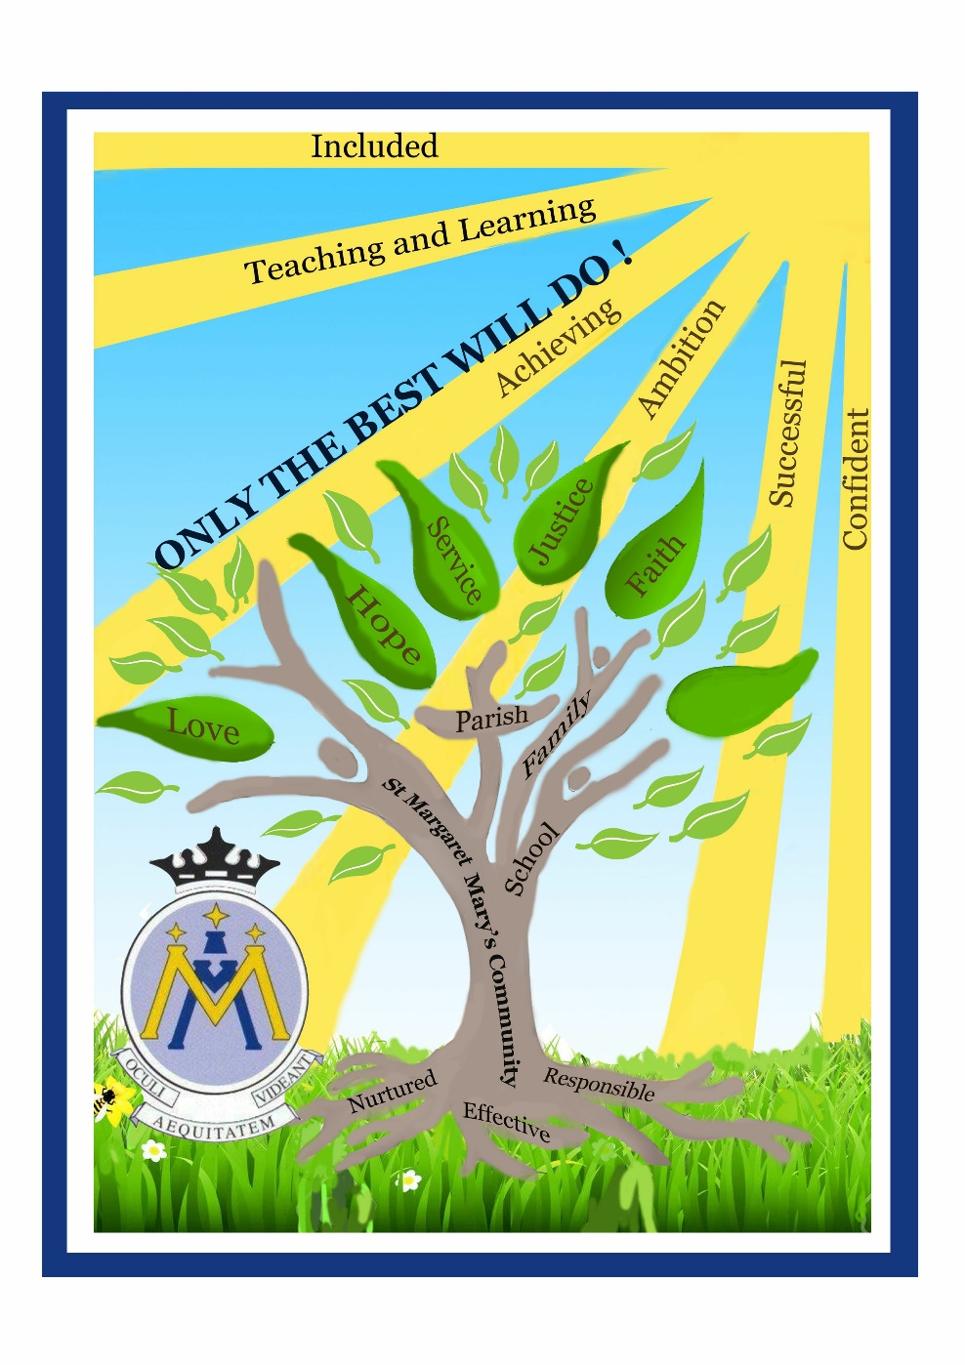

Grand Challenges | How | When | How will we know
- Continue to improve Learning and Teaching in classrooms | - All teachers working on all pupils enjoying lessons/learning | - June 2026 | - Pupil Parliament  - Pupil focus groups  - evaluations
- Continue to focus on the wellbeing of all pupils | - RRSA  - Vision, Values and Aims  - Wellbeing supports for everyone  - Positive relationships policy | - June 2026 | - Pupil Parliament  - Pupil focus groups  - evaluations
- Continue to improve pupil voice | - We can influence decisions made about our school  - Introduce QR codes for feedback/suggestions  - We can speak at assemblies  - Use notice boards and screens in canteen to show our work | - June 2026 | - Pupil Parliament  - Pupil focus groups  - evaluations

