St Margaret Mary’s
Secondary School

School Handbook
Last updated October 2025


A School at the Heart of the Community



St Margaret Mary’s Secondary School
Handbook 2025

Welcome to our school
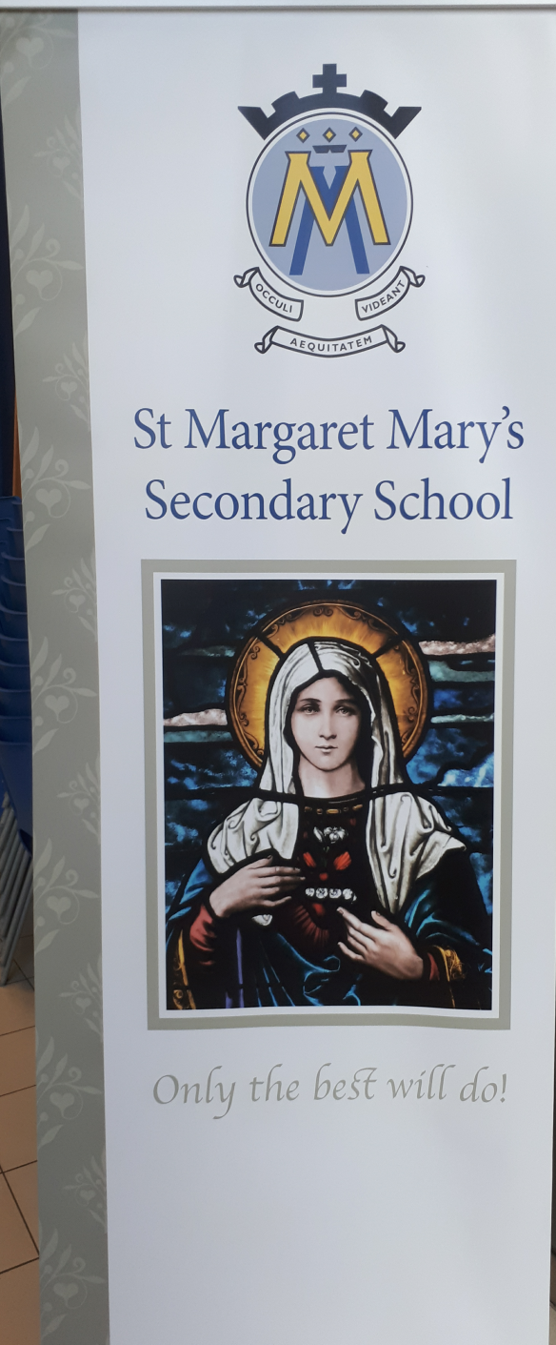
It gives me great pleasure to welcome you to St Margaret Mary’s Secondary School. As you look through this handbook you will see our Vision, Values and Aims clearly stated, these are the essence of our school community. St Margaret Mary’s is an inclusive and nurturing comprehensive Catholic school.

In St Margaret Mary’s we are engaged in the pursuit of excellence. We are a Catholic school and each member of our community is held in high regard and their dignity and individuality are respected. We have a distinctive Catholic ethos and this is reflected in our regular prayer and worship. We have high expectations for every child in the school and we promote the spiritual, physical, social, emotional and intellectual development of the young people as they move into adulthood.

St Margaret Mary’s offers a curriculum characterised by the highest standard of learning and teaching. The schools purpose is to help all young people achieve their very best potential. We are committed to developing them for life and ensuring that they become successful learners, confident individuals, responsible citizens and effective contributors.

I welcome, encourage and value your involvement in the education of your child. Together as a community I believe that we can work to reach the highest standards of attainment and achievement for our young people.

Finally, I hope this handbook provides you with lots of useful information and please contact us if you require further information.

Mr D O’Neill
Head Teacher

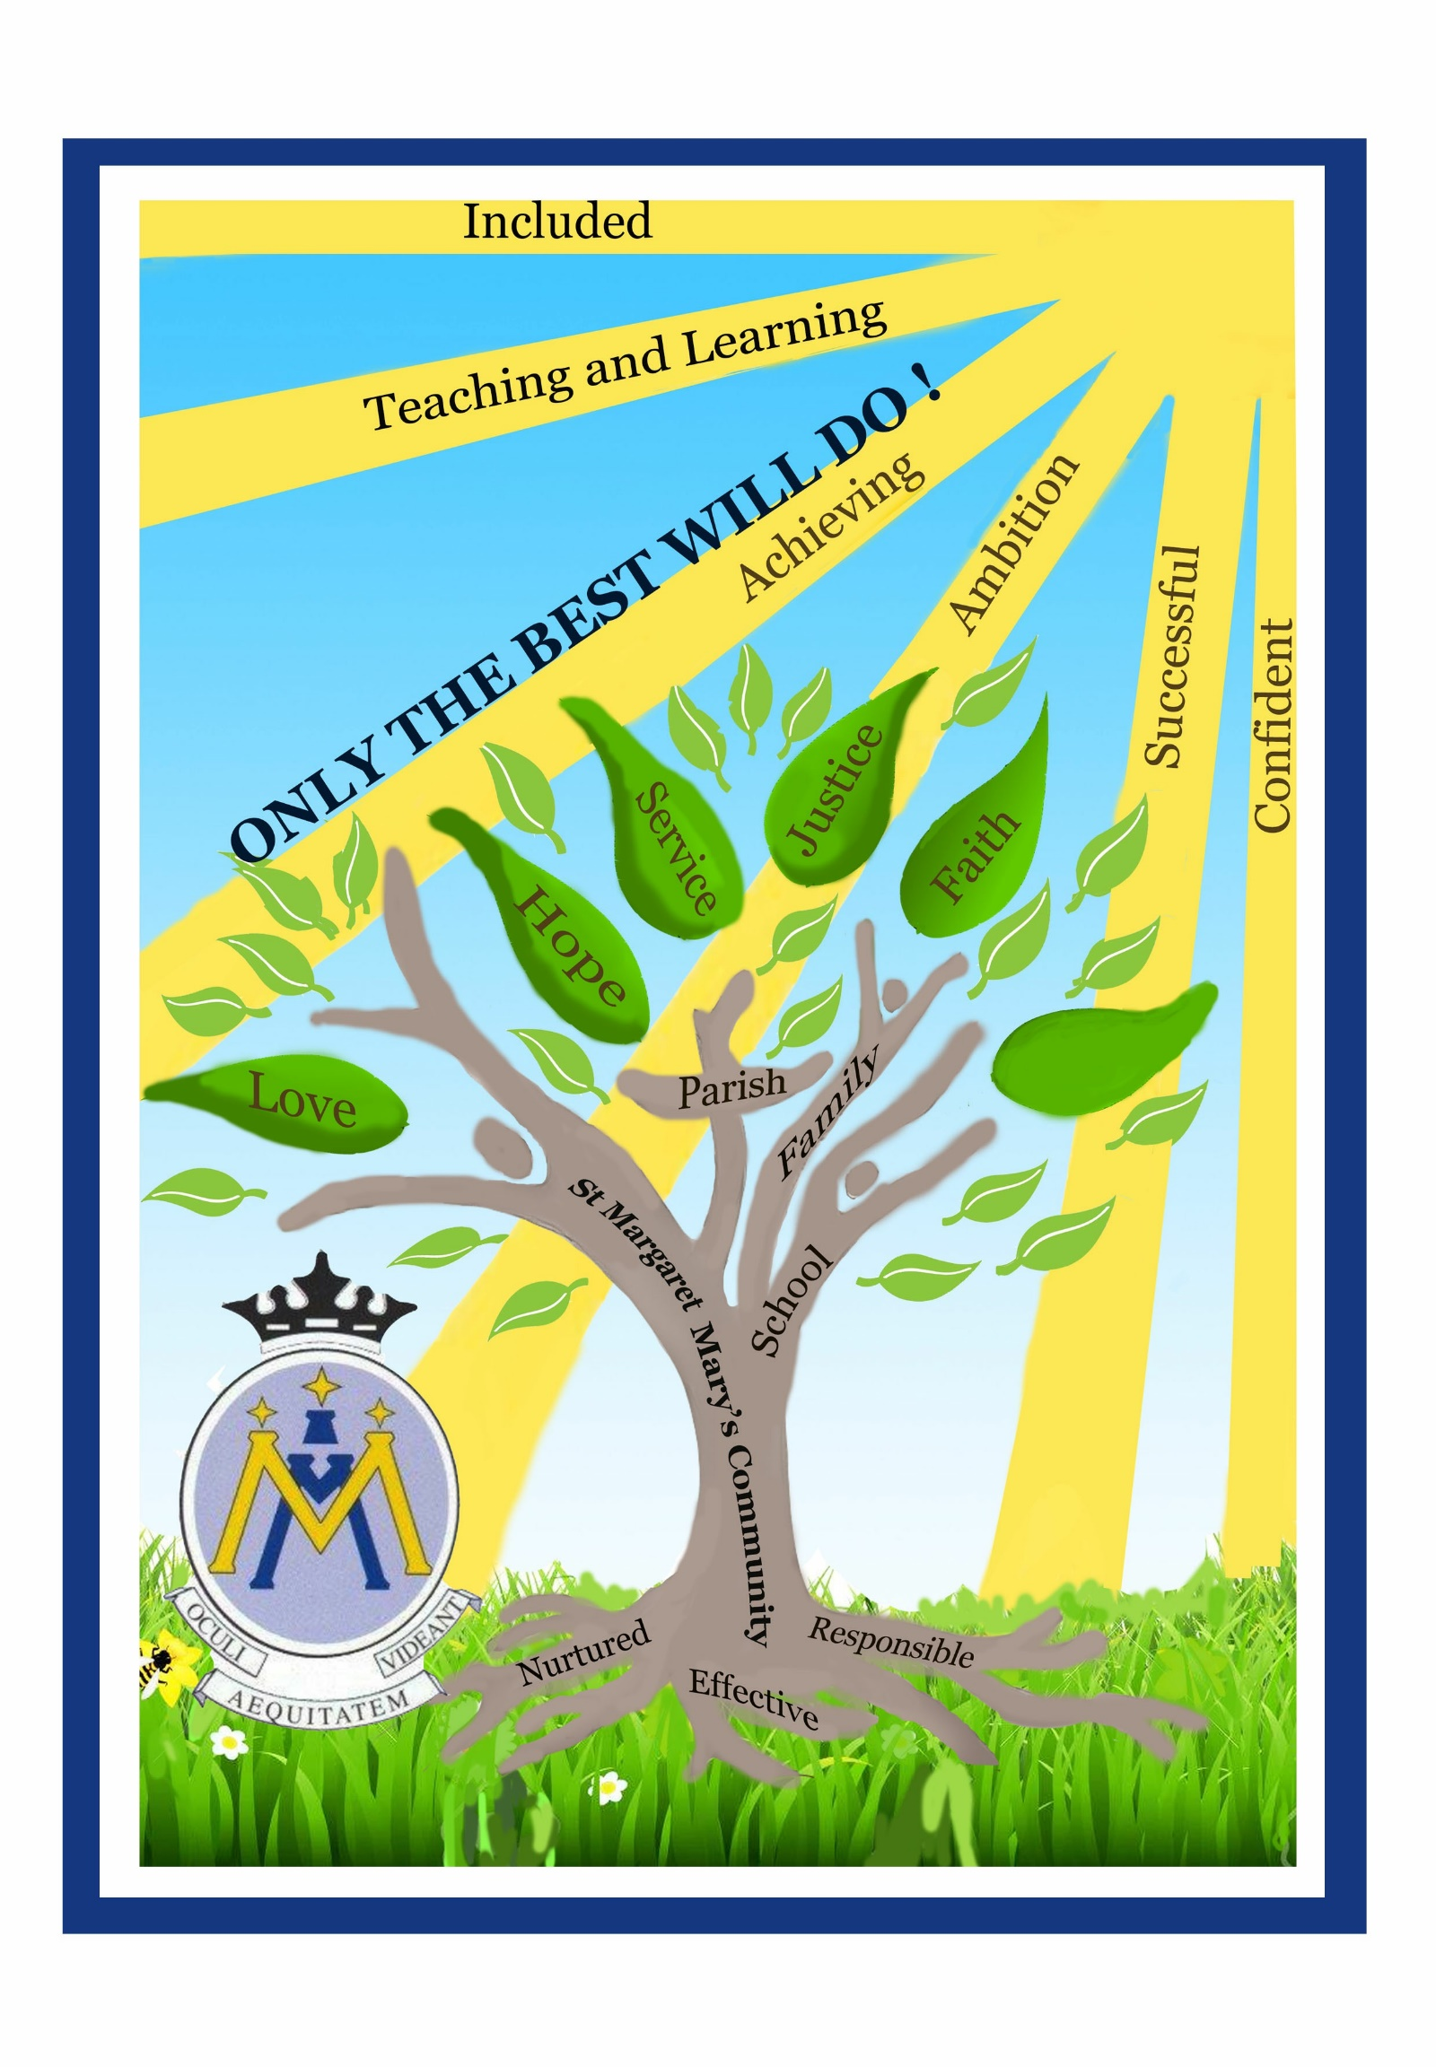

School Information

You can cut out the following information and have it on your fridge, purse or work desk etc.
for ease of finding the numbers required.

Contact Details

St Margaret Mary’s Secondary School
9 Birgidale Road
Castlemilk
G45 9NJ

Phone: 0141 582 0250
Email: headteacher@st-margaretmarys-sec.glasgow.sch.uk
Website: www.st-margaretmarys-sec.glasgow.sch.uk
Twitter: @stmargaretglas

T

Background information:

- Co-educational school
- Roman Catholic
- Stages taught: S1-S6
- Current Roll: 440
- Capacity: 600

School staff:

A full list is available on the school website and parents will be updated on any changes as
required.

The Senior leadership team is as follows:



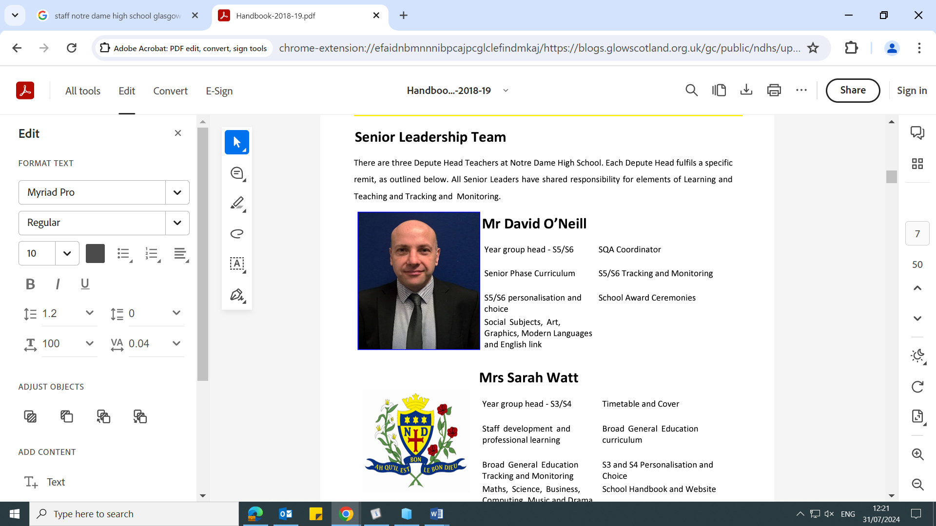

Headteacher Depute (S1) Depute (S2-S3) Depute (S4-S6)
Mr David O’Neill Mrs Lyndsay Malley Mrs Amanda Moore Mrs Susan Wilson

Moving from Primary to St Margaret Mary’s Secondary

We recognise that the move from primary to secondary is a very important event for young people. We have a close and effective partnership with each of our partner primary schools, St John Paul II Primary and St Bartholomew’s Primary. This ensures that the move from primary to secondary is as smooth as possible for young people.

We welcome families from outwith our area. Families living outwith the school catchment area are welcome to make a placing request to attend St Margaret Mary’s Secondary. Prospective parents are welcome to visit our school and should contact the school office.






Further information is available on
www.glasgow.gov.uk/education

Our School Day
MONDAY | TUESDAY | WEDNESDAY | THURSDAY | FRIDAY
Registration  8.50am-9.00am | Registration  8.50am-9.00am | Registration  8.50am-9.00am | Registration  8.50am-9.00am | Registration  8.50am-9.00am
PERIOD 1  9.00am--9.50am | PERIOD 1  9.00am--9.50am | PERIOD 1  9.00am--9.50am | PERIOD 1  9.00am--9.50am | PERIOD 1  9.00am--9.50am
PERIOD 2  9.50am-10.40am | PERIOD 2  9.50am-10.40am | PERIOD 2  9.50am-10.40am | PERIOD 2  9.50am-10.40am | PERIOD 2  9.50am-10.40am
INTERVAL
10.40am – 10.55am
PERIOD 3  10.55am-11.45am | PERIOD 3  10.55am-11.45am | PERIOD 3  10.55am-11.45am | PERIOD 3  10.55am-11.45am | PERIOD 3  10.55am-11.45am
PERIOD 5  12.35pm-1.25pm | PERIOD 5  12.35pm-1.25pm | LUNCH  12.35pm – 1.15pm | LUNCH  12.35pm – 1.15pm | LUNCH  12.35pm – 1.15pm
LUNCH  1.25pm-2.05pm | LUNCH  1.25pm-2.05pm | PERIOD 5  1.15pm – 2.05pm | PERIOD 5  1.15pm – 2.05pm | PERIOD 5  1.15pm – 2.05pm
PERIOD 6  2.05pm - 2.55pm | PERIOD 6  2.05pm - 2.55pm | PERIOD 6  2.05pm - 2.55pm | PERIOD 6  2.05pm - 2.55pm | PERIOD 6  2.05pm - 2.55pm
PERIOD 7  2.55pm-3.45pm | PERIOD 7  2.55pm-3.45pm

School Holidays 2025-2026

Details of holiday dates are available on Glasgow City Council website:
www.glasgow.gov.uk/article/4276/School-Term-Dates
October
- Friday, 10 October 2025 (In-Service Day)
- Monday, 13 to Friday, 17 October 2025 (October Week)

December - Christmas and New Year
- Schools close at 2.30 pm on Friday, 19 December 2025
- Monday, 22 December 2025 - Friday, 2 January 2026 (Christmas holidays)

January
- Schools return on Monday, 5 January 2026

February mid term break
- Monday, 16 February 2026
- Tuesday, 17 February 2026
- Wednesday, 18 February 2026 (In-service day)

April - Spring Holiday (Easter)
- Schools close at 2.30 pm on Thursday, 2 April 2026
- Friday, 3 April 2026 (Good Friday)
- Monday, 6 April - Friday, 17 April 2026 (Spring Break)
- Schools return on Monday, 20 April 2026

May
- Monday, 4 May 2026 (May Holiday)
- Thursday, 7 May 2026 (In-service day to coincide with Scottish Parliamentary election, but may be subject to change)
- Friday, 22 May 2026 and Monday, 25 May 2026 (May Weekend)

June
- Schools Close at 1.00 pm on Thursday, 25 June 2026

Pupil Absence

Within St Margaret Mary’s Secondary School excellent attendance is encouraged at all times to ensure pupil success. Parents are asked to inform the Pupil Absence Reporting Line on 0141 287 0039 if their son or daughter is going to be absent. This should be done as early as possible on the first day of absence, lines are open from 8am-3.30pm, Monday to Friday. Alternatively, you can use the online form on the Glasgow City Council Website at
https://www.glasgow.gov.uk/pupilabsence

If the young person is going to be absent for some time, it would be helpful to know at the earliest opportunity.

Our school uses daily text messaging to inform parents/carers of a young person’s absence if no contact has been made. All unexplained absence is investigated by the school and appropriate action taken.

Medical & Healthcare

NHS staff visit at various times during the year for routine vaccinations. Parents and carers are kept informed by letter.

If a young person becomes ill during the course of the school day, he/she may require to be
sent home. Please ensure that you keep the school informed of all contact details.

Parents and carers should inform the school of any medical requirements relating to their
child. If a young person requires medication during the school day, parents must complete
the appropriate medical form. This is available on request from the school office.

Emergencies

We make every effort to maintain a full educational service, but on some occasions
circumstances arise which lead to disruption. Schools may be affected by, for example,
severe weather, temporary interruption of transport, power failures or difficulties of fuel
supply.

In such cases, we shall do all we can to let you know about the details of our closure or reopening by using letters, texts and the local media etc.

School Dress Code

Our school uniform promotes a real sense of school identity, shared values, self-confidence
and a shared sense of community. The uniform is actively supported by our pupils, parents
and the Parent Council and is of great benefit to our young people.

The school uniform is:
- Formal black leather school shoes or plain black ‘trainers’ with no coloured badges, logos, laces or soles (black socks/tights).
- Formal white school shirt with collar (no blouses, polo shirts, T shirts).
- Plain black school trousers or skirt of appropriate length (NO jeans, leggings, jogging bottoms, shorts etc.).
- Plain black ‘V neck’ jumper or cardigan.
- Plain black blazer with school badge and lower school tie for all S1-S4 pupils
- Black blazer with blue braiding and school badge and senior tie for all S5/6 pupils.


The school ties are available from the school office and the blazer supplier visits the school on
an annual basis. The school office can advise on how to obtain a blazer outwith this time.

PE Kit

It is important that pupils come prepared to learn and for PE this requires appropriate
clothing. All jewellery should be removed. Pupils who are not participating in PE must have
a medical certificate. Pupils who are unable to participate in practical PE should still bring
their kit to allow them to assist in the lesson by refereeing, keeping scores or assisting with
the distribution of equipment. This ensures that they are still able to take part in some way
in the work of the class and do not miss out on the knowledge and understanding of the
course.

There are forms of dress that are unacceptable in school, such as items of clothing which:


- Potentially encourage factions
(such as football colours)
- Could cause offence
(such as anti-religious symbolism or political slogans)
- Could cause health and safety difficulties
(such as loose fitting clothing, jewellery)
- Could cause damage to flooring
- Carry advertising particularly for alcohol or tobacco
- Could be used to inflict damage on other pupils

Clothing & Footwear Grants
You may be eligible for a school clothing grant if you have a child that attends a Glasgow school and you receive any of the following benefits:
• Housing Benefit/ Council Tax Reduction (this is not Council Tax single person's discount or student discount)
• Universal Credit (UC) (check link below for thresholds).
• Income Support/Income based Job Seeker's Allowance (JSA) (check link below for thresholds).
• Working Tax Credit and Child Tax Credit (check link below for thresholds).
• Support under Part VI of the Immigration and Asylum Act 1999
Information and application forms may be obtained at
www.glasgow.gov.uk/media/6145/Clothing-Grant-Free-School-Meal-Application-Guidance/pdf/CGFSM_Application_Guidance_for_Parents_Carers_2526_002.pdf?m=1749453922850

School Meals

Our school provides a lunch service which offers a variety of meals and snacks within The Fuel Zone. A breakfast and mid-morning service is also available within The Fuel Zone. Special diets for children with medical requirements can be provided. Please inform the school office.

Young people who prefer to bring packed lunches are accommodated in the dining hall.
Fuel Zone provides a broad choice of balanced meals

You may be entitled to a free midday meal if you receive any of the benefits listed below.

Free School Meal - Eligible Benefits
- Income Support
- Income based Job Seekers allowance
- Working Tax Credits (check link below for thresholds)
- Child Tax Credits (check link below for thresholds)
- Universal Credit (check link below for thresholds)
- Income related Employment and Support Allowance - please provide a copy of your award letter dated within the past 3 months.

Further information and application forms for free school meals can be found at https://www.glasgow.gov.uk/schoolsandlearning

Transport

The education authority has a policy of providing free transport to all young people who live out with a certain radius from their local school by the recognised shortest walking route. This means that the provision of transport could be reviewed at any time. Parents/Carers who consider they are eligible should obtain an application form from the school or at https://www.glasgow.gov.uk/media/6134/Home-to-School-Transport-Guidance/pdf/Home_to_School_Transport_Guidance_2024.pdf?m=1722502178943

Communication with Parents

At St Margaret Mary’s Secondary School we strongly encourage all parents to become involved in the education of their children. We are always ready to listen to suggestions for new ways of stimulating parental interest. We contact and involve parents in many ways. For example:

Newsletters – will be sent out on a regular basis to keep parents and carers informed about the work of the school.

Letters – further information which requires a response may be sent out in letter form.

Online - School Website/Twitter – will contain a great deal of information about the school. It is a good idea to check this regularly.
http://www.st-margaretmarys-
sec.glasgow.sch.uk
Follow us:
@stmargaretglas

Text messaging – You may also receive text reminders about events/school closures etc.

Meetings - Parents and carers are welcome in the school to discuss any aspect of their child’s development and progress. To avoid disappointment, it is advisable to make an appointment. There are various opportunities throughout the year when parents can discuss their child’s progress with school staff.

Parents and carers are welcome at other events throughout the school year e.g. workshops, information evenings, class performances, award ceremonies, religious and other assemblies. The school newsletter, App and website will keep you informed.

Strong communication links between home and school ensure parents and carers are confident to address any concerns they may have about their child’s education with pastoral care staff and the senior leadership team.
Emergency Contact Information

At the start of each school session, parents and carers will be issued with the annual data check form. Please ensure that this is completed and returned to the school. It is also important that you let us know if there are changes to your telephone number(s) or to those of your emergency contacts throughout the year.

Data Protection
Use of Information about Children and Parent/Carer

We collect information about children and young people attending school (and also about parents/carers, emergency contacts etc. provided in the annual data check) to allow us to carry out the Council’s functions as the education authority for the City of Glasgow. This may sometimes involve releasing personal information to other agencies and other parts of the Council, particularly in relation to child protection issues or criminal investigations, and it may also be used for research purposes (see the link below for more details regarding this).

Information held by the school is, in legal terms, processed by Glasgow City Council. The Council is registered as a data controller under the Data Protection Act 2018 and all personal data is treated as confidential and used only in accordance with the Data Protection Act , the General Data Protection Regulations and the Information Use and Privacy Policy approved by the City Council. For more information on how we use personal information, or to see a copy of the Information Use and Privacy Policy, see Data Protection and Freedom of Information - Glasgow City Council

Education specific privacy statements can be accessed at:
www.glasgow.gov.uk/article/5761/Home-Education-Privacy-Statement

Appointments During School Hours

If your child has an unavoidable appointment, please give them a letter for their tutor teacher / pastoral care teacher to ensure that they have permission be absent from class.

Comments & Complaints

In St Margaret Mary’s Secondary School we aim to have positive relationships across our school community. However, if you have a comment or complaint about any aspect of school life, please contact the relevant Year Head in the first instance.

Glasgow City Council complaints procedures are available:
https://www.glasgow.gov.uk/complaints

Customer Care Team
Customer & Business Services
Glasgow City Council
City Chambers
Glasgow
G2 1DU

Phone 0141 287 0900
e-mail: customercare@glasgow.gov.uk or
education.customerservices@glasgow.gov.uk
The above website also includes information on data protection and freedom of information.

Curriculum

Curriculum for Excellence 3-18

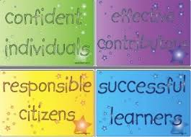
Curriculum for Excellence has been introduced to raise standards of learning and teaching for all 3 to 18 year olds. It aims to help prepare children and young people with the knowledge and skills they need in a fast changing world. As part of Curriculum for Excellence, all children from pre-school to the end of S3 will receive a rounded education known as a Broad General Education (BGE). Curriculum for Excellence is all about bringing real life into the classroom and taking lessons beyond it.

In line with their Curriculum for Excellence entitlement, pupils learn in all 8 curricular areas until the end of S3.

Expressive Arts | Health & Wellbeing | Languages | Mathematics
Religious & Moral | Sciences | Social Studies | Technologies

There is also a focus on developing literacy and numeracy skills across every subject area as well as Skills for Learning, Life and Work as young people prepare for their adult lives. In addition, learning takes place in the following ways:

- Inter-disciplinary experience (working across a range of subjects to link learning)
- Learning through the ethos and life of the school
- Opportunities for personal/wider achievement

The Senior Phase S4-S6

The Senior Phase offers opportunity for specialisation leading to qualifications. Young people aged 15 plus will have a wide range of opportunities to experience learning and achieve qualifications to the highest possible level during their senior phase.

Throughout S3, there is a programme of pupil support to assist pupils and their parents and carers with course choices for National 4 and National 5 awards. The pupil support programme seeks to advise pupils about:

- The range of courses available
- The pupil’s own aptitudes, interests, strengths and areas for development
- The importance of individual subjects
- Entrance qualifications & career opportunities

In advising pupils about course choices, we adhere to national guidelines and ensure that pupil choices result in their best chance of success.


In collaboration with the Scottish Qualifications Agency (SQA), we will assess National 1 to 4 qualifications. Individual courses at National 1 - 4 levels will not be graded but marked overall as pass or no award.

Courses at National 5, Higher and Advanced Higher levels will continue to include work assessed by the school, but for these qualifications, students will also have to pass an additional assessment (usually a question paper or assignment) which will be marked externally by SQA.

Theses websites contain useful information to help you understand national qualifications:

https://www.sqa.org.uk

Courses Available in S5 & S6

As an inclusive school, we aim to meet the needs of all pupils in S5 and S6. We have strong partnerships with local schools, colleges, universities and employers. It is extremely important that senior students set challenging and realistic targets. To that end, we offer a rigorous options programme to support and inform student choice. Opportunities for personal development continue within and beyond the taught curriculum. S6 in particular offers senior pupils a range of opportunities to build leadership, communication and team working skills through involvement in a wide range of school and community events.

Encouraging excellence is central to our aspirations and expectations for all young people as highlighted on our school motto “Only the Best Will Do.”

Religious Observance


Our school is fortunate to have a close link with the local parishes. Our school Chaplain is Father Vincent. Our Principal Teacher of RE is Miss Claire Scanlon. Both assist with the Christianity element of Religious and Moral Education and provide opportunities for religious observance.

In addition, parents and carers from religions other than Christianity may request that their children may be permitted to be absent from school in order to celebrate recognised religious events. Only written requests detailing the proposed arrangements will be considered. Appropriate requests will be granted on up to 3 occasions in any 1 school session.

Useful Websites

Education Scotland – www.education.gov.scot
National Parent Forum of Scotland – www.npfs.org.uk
Parentzone – https://education.gov.scot/parentzone/
Connect – https://connect.scot/

Assessment & Reporting

All young people are assessed both formally and informally throughout the school year. This allows young people and their teachers to identify their strengths and areas for improvement. A variety of assessment methods are used to enable staff to pass on information to parents and carers about the progress of their child. Assessment records are kept by teachers and form the basis of discussion at parents’ meetings throughout the year.

Dates of all parents’ meetings and the schedule for issuing written reports is included in the school calendar which is issued at the start of term and is available on the website.

If you have any concerns about your child’s progress do not hesitate to contact their pastoral care teacher at any time.

Pupil Profiles

All S3 learners have a profile which reflects their progress in learning and achievement and emphasis their strengths. The profile documents their key achievements in school, at home and in the community and the content is decided by the young person. The profile provides a valuable way for learners to share information about their achievements with their parents, teachers and in the future, staff in colleges, universities and employers. The profile also supports the move from S3 into the senior phase of secondary school.

Support for Pupils

The school has a duty to ensure that all pupils have equal access to the curriculum, with appropriate support for their needs if required. This applies to the content of lessons, teaching strategies and minor adaptations to the school environment. There are a wide range of factors which may act as a barrier to learning. We are committed to working closely with parents and carers to ensure that they are fully involved in any decisions about support for their children’s needs.

Any parent or carer seeking further advice regarding this policy should contact the Headteacher in the first instance.

Further information relating to additional support needs is available on the Glasgow City Council website –
Meeting Additional Support Needs - Glasgow City Council

Information on the Glasgow City Councils’ Parental Involvement Strategy can also be found at www.glasgow.gov.uk/article/5518/Parental-Involvement

Pupil Support Staff

All staff in St Margaret Mary’s Secondary School have a clear responsibility for the welfare of young people. In addition, all young people are given a Pastoral Care teacher on entering the school. This provides a vital link between home and school as the pastoral care teacher has an ‘all-round’ picture of a pupil’s progress and general health and well-being. In most cases, a parent’s first point of contact with the school will be the pastoral care teacher.

Other support for pupils is provided by class tutors in the first 10 minutes of each day and by the Inclusion Team, School Counsellor and a Youth Worker, as required.

We are fully committed to meeting the needs of all pupils and hold regular meetings at which we plan for those who might benefit from additional support. Full discussion is held with parents and carers and outcomes are planned and agreed in partnership.



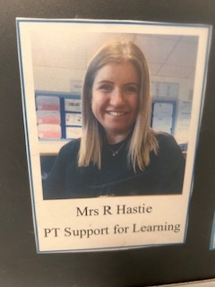




Mr Tracey Ms Alexander Mrs Wilkin Mrs Madden Mrs Hastie
PTPC PTPC PTPC PTPC PTPC
St Andrew St Benedict St Catherine Support for Learning

Child Protection

All educational establishments and services must take positive steps to help children protect themselves by ensuring that programmes of health and personal safety are central to the curriculum and should have in place a curriculum that ensures that children have a clear understanding of the difference between appropriate and inappropriate behaviour on the part of another person, no matter who.

As with other areas of the curriculum, you will be kept informed of the health and wellbeing programme for your child’s establishment.

Educational establishments and services must create and maintain a positive ethos and climate which actively promotes child welfare and a safe environment by:

ensuring that children are respected and listened to;

- ensuring that programmes of health and wellbeing are central to the curriculum;

- ensuring that staff are aware of child protection issues and procedures;

- establishing and maintaining close working relationships and arrangements with all other agencies to make sure that professionals collaborate effectively in protecting children.

The name of the Child Protection Coordinator is Mrs A Moore and depute Child Protection Coordinator is Mrs S Wilson. These details are on display within the school.

Nurturing City

The Glasgow City Council vision ‘towards the nurturing city’ puts building positive, trusting relationships at the core of our work. We ensure children, young people and families feel they belong, they are listened to and they are valued by embedding the principles of nurture across our early years, primary and secondary establishments. Staff are trained in attachment and nurture which deepens understanding of child development and enhances effective practice by responding to the needs of all children and young people in a consistent and caring way. Nurture is a universal approach which builds resilience, helping to reduce the impact of adversity. Effective communication and collaboration with parents and carers builds an ethos of partnership working putting the child at the centre, fostering high quality learning contexts.

Each of our nurturing establishments contribute to the development of Glasgow as a nurturing city, creating safe environments which allow our children and young people to flourish by raising attainment and promoting positive mental health and wellbeing.

Promoting Positive Behaviour

Children’s Rights as outlined in the UNCRC (United Nations Convention on the Rights of the Child) are fundamental to a good school ethos. Adults in our school will work with young people to ensure they are aware of their rights and fully respect the rights of others. Therefore, the approach within St Margaret Mary’s Secondary School is to build a positive ethos that demonstrates care and respect for all.

The smooth running of St Margaret Mary’s Secondary School requires a high standard of behaviour from all within it. We appreciate the support of parents and carers in helping us to achieve this. All pupils are required to behave well and respect their own safety and that of others. This is also important on journeys to and from school.

Our expectations are clearly communicated to young people and inappropriate behaviour is dealt with in line with school policy.


Pupils designed
anti-bullying posters

Homework

Regular, effective homework is an important part of the school day. To this end, every young person in the school has been provided with a Homework Diary. Parents are asked to check this on a regular basis. Homework has many advantages:

- It reinforces work done in class
- It develops good study habits and a sense of
- personal discipline
- It develops areas of interest that can be
- followed up later in life and become a leisure pursuit
- It allows parents to see, help and become involved in their child’s work

The amount of homework varies in length, nature and frequency depending on the subject. The amount of homework will increase as your child progresses through the school.

Supported Study

This is an important initiative which allows pupils to attend additional classes during lunchtimes, after school and during holiday periods. Large numbers of our staff give generously of their time in this area. Subjects on offer will depend on the staff available to deliver. Pupils will be kept informed of the arrangements which can found on our website and on our school app.

Parent Council
We have a Parent Council that represents the views of all parents. All parents are welcome to attend Parent Council meetings and can become members at any time. Parent Council minutes are available on the Parent Council page of the school website and on request from the school office.

Pupil Parliament

Our Pupil Parliament is made up of 2 representatives from each year group. This is an important group which ensures that the views of pupils are heard. The school also has a Senior Pupil Leadership Team to further promote pupil voice.


Pupil Council promoting the Christmas Jumper Day for SCIAF

Extra Curricular Activities

We have a wide range of activities that run between Monday – Friday to extend the learning experience. Details of all extra-curricular activities can be found on our website and our school app. All young people are involved in a weekly Wider Achievement afternoon.

Good links with community organisations and our Active Schools Co-ordinator are vital for the success of these programmes.

An Example of some of our extra-curricular activities

Football
S1 Lunchtime Breakfst Club 
S1 Lunchtime Badminton
Under 14s team Gymfest
Under 15s team Gymnastics
S1 Boys team Dance
Girls team Ski trip
Fitness lunchtime
Netball






School Improvement

On an annual basis, you will receive a copy of our Standards and Quality report. The Standards and Quality report will be used to share the overall exam performance of the school and highlights progress in key curricular areas such as literacy, numeracy and health & wellbeing. Our priorities for improvement are detailed in our School Improvement Plan which is discussed with our Parent Council. Any parent or carer seeking a copy of the plan can contact the school office or check out our website.

Useful Contacts

Parentzone Scotland is a unique website for parents and carers in Scotland, from early years to beyond school. The website provides up-to-date information about learning in Scotland, and practical advice and ideas to support children’s learning at home in literacy, numeracy, health and wellbeing and science. Information is also available on Parentzone Scotland regarding additional support needs, how parents can get involved in their child’s school and education. Furthermore, the website has details about schools including performance data for school leavers from S4-S6; and links to the national, and local authority and school level data on the achievement of Curriculum for Excellence levels.

Useful websites and contacts

Education Scotland www.education.gov.scot
National Parent Forum of Scotland www.npfs.org.uk
Parentzone https://education.gov.scot/parentzone/

Connect

Connect is a national organisation that provides advice and resources for parents and carers. www.connect.scot

Enquire Scotland

Enquire is a national advice service for families with additional support needs. www.enquire.org.uk

Education Services
City Chambers East
40 John Street
Glasgow G1 1JL
Tel: 0141 287 2000
www.glasgow.gov.uk



